Numerical Methods to PDEs

Homework#4

Chen Zhang

**Problem 1)**

1. We have the function as:  , with .

The function has a singular point at . From the function we know that when , the function is square integrable ,thus f is in space , which means the error of using Lagrange functions to approximate f will converge to zero. When, the function is not in space , thus the error will not converge to zero.

1. =0.05 =0.1

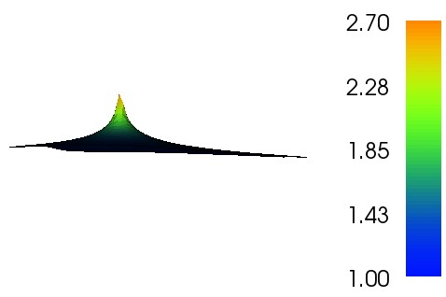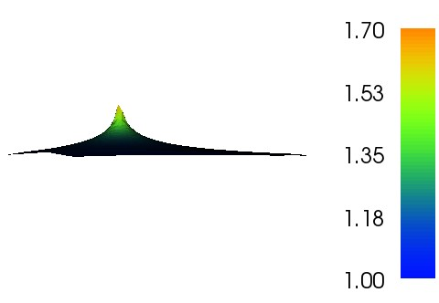

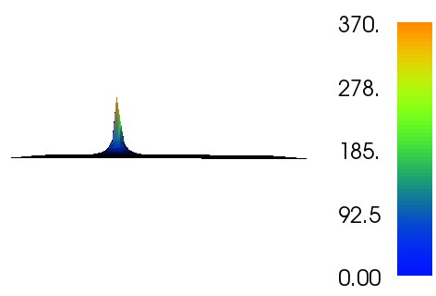=0.3 =0.6

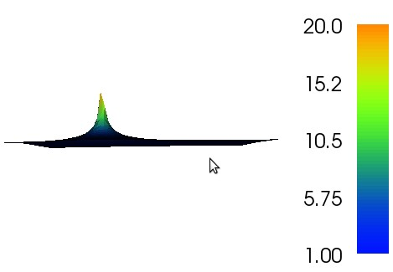

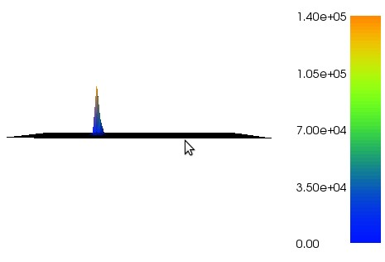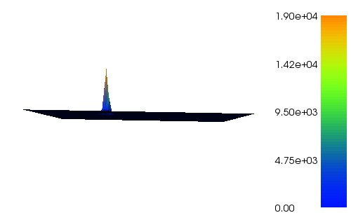 =1 =1.2

We can clearly see from the figures that as increases, the level of singularity at  also increases.

The rate of convergence for different  is recorded in the following chart:

|  |  |  |  |  |  |  |
| --- | --- | --- | --- | --- | --- | --- |
| $$α$$ | 0.05 | 0.1 | 0.3 | 0.6 | 1 | 1.2 |
| Average convergence rate in L2 error norm | 0.8996337 | 0.7997588 | 0.3999522 | -0.2 | -1. | -1.4 |

**Problem 2)**

1. The Poisson Problem with Dirichilet boundary conditions can be stated as below:

 in 





1. =0.1

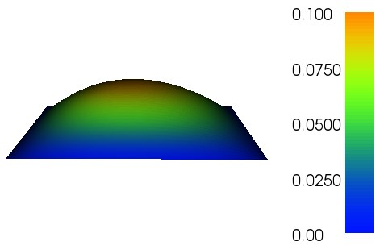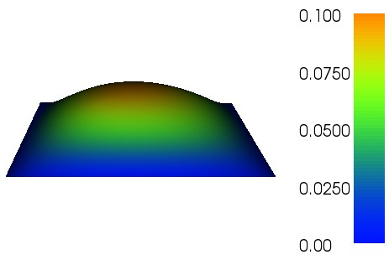Exact Solution Approximate Solution

=0.3

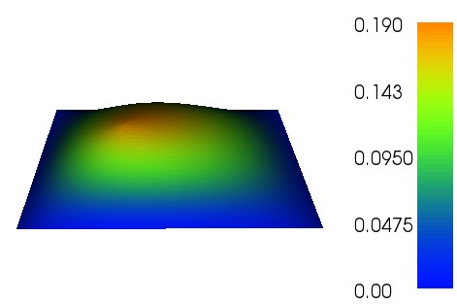Exact Solution Approximate Solution

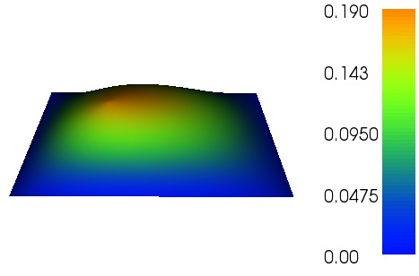

=0.6

Exact Solution Approximate Solution

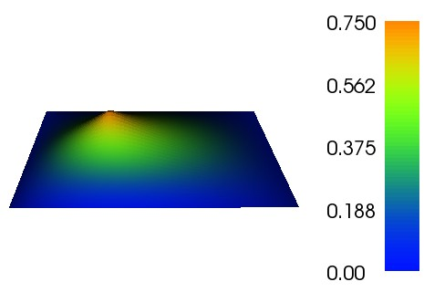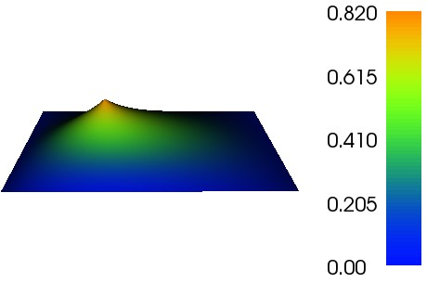

=1

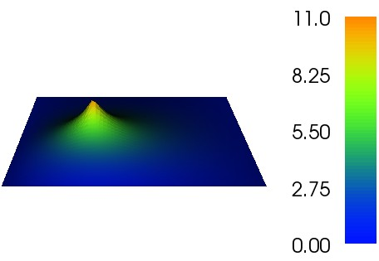Exact Solution Approximate Solution

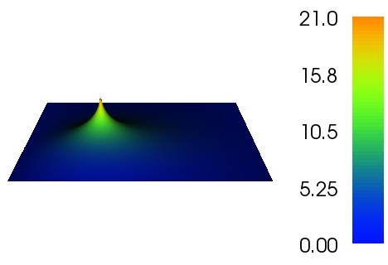

=1.5

Exact Solution Approximate Solution

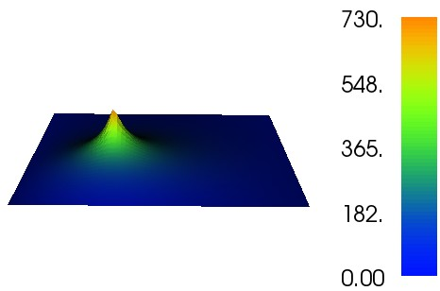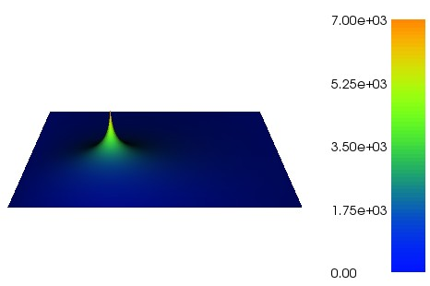

=2

Exact Solution Approximate Solution

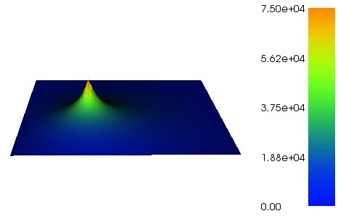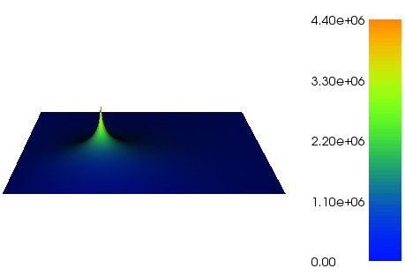

|  |  |  |  |  |  |  |
| --- | --- | --- | --- | --- | --- | --- |
| $$α$$ | 0.1 | 0.3 | 0.6 | 1 | 1.5 | 2 |
| L2 error norm | 1.9844228 | 1.7348057 | 1.0245428 | 0.3778766 | 0.07375015 | 0.0117651 |
| H1 error norm | 0.9934757 | 0.9968814 | 0.7978020 | 0.25951405 | -0.0228169 | -0.088027 |

From the figure and the chart we can see that whether or not the right hand side of the equation is integrable will have an effect on the convergence of FEM solution. From the chart we can see that if , which means the right hand side is not integrable , the FEM will have a large error even with a very refined mesh, and the convergence rate is very low and even not converging.

For the cases when  is very small, the convergence rate is very close to the theoretic convergence rate: for the error norm of  it is 2 and for the error norm of  it is 1.

**Problem 3)**

1. The exact solution is given by



In polar coordinates, the Laplacian operator can be written as



where

 and 

Plug the equations in , we will have the following result





Therefore the exact solution is the solution to the Laplace problem

Also, since the domain is not smooth and convex, then the solution is not in .

1. Mesh refinement level 1 Mesh refinement level 2

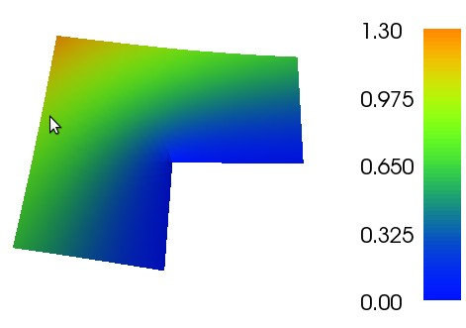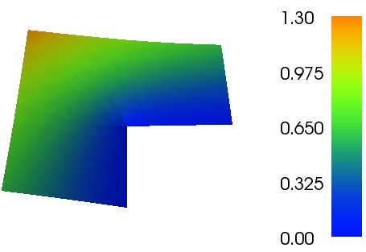

Mesh refinement level 3 Mesh refinement level 4

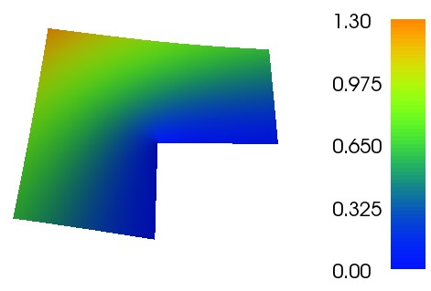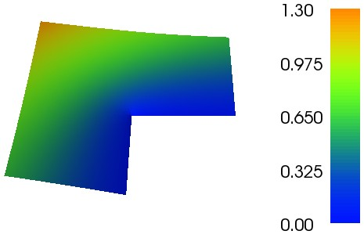

The convergence of FEM solution by means of  error is listed in the table below:

|  |  |  |  |  |  |  |
| --- | --- | --- | --- | --- | --- | --- |
| Refinement Level | 1 | 2 | | 3 | | 4 |
| Hmax | 0.2874 | 0.1437 | | 0.0719 | | 0.0359 |
| L2 error norm | 5.92E-03 | 2.40E-03 | | 9.70E-04 | | 3.91E-04 |
| Convergence rate | 1.30218 | | 1.30644 | | 1.31201 | |

**Problem 4)**

1. The formulation of the problem is as below:

From the equation



We can write it in the form:



, , 

In which q is an unknown vector field and u is an unknown scalar field. We can solve the problem by using mixed FEM. Two spaces are used for q, one is vector Lagrange Space (H(1)), and the other one is the Raviart-Thomas space (H(div)). The scalar field is always assumed to be in constant space (DG of order 0).

1. The exact solution is :

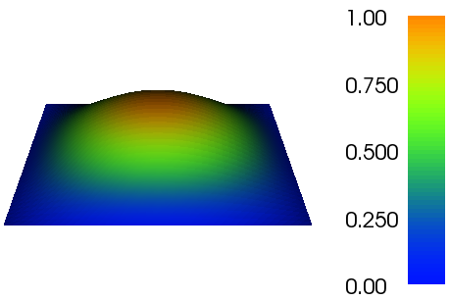

When q is in H(div) space, the solution is plotted as below(50*50 mesh on a unit square):

Scalar field u vector field q

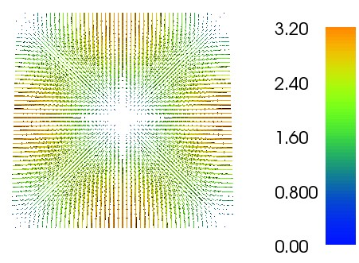



When q is in H(1) space, the solution is plotted as below(50*50 mesh on a unit square):

Scalar field u vector field q

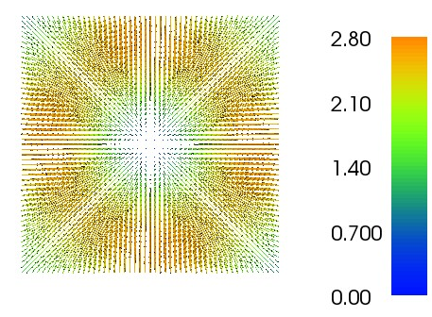

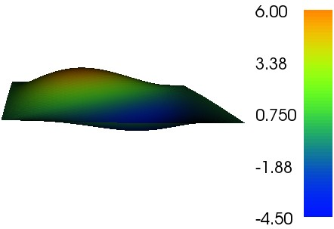

Because the H(div) space and H(1) space place different constraints on the trial functions, therefore the nature of the trial functions we are using are different, which will lead to different FEM results. Also, H(div) space includes H(1) space, meaning that the definition for H(div) space is wider and incorporates more functions, therefore the H(1) space should perform better on a uniform square as in the problem.